How to dispose used and unwanted inhalers
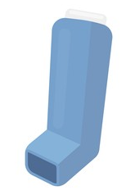
The propellants in commonly used inhalers are powerful greenhouse gases.
Even after the inhaler has been used, significant amounts of these environmentally damaging gases remain in the canister.

Landfill disposals of inhalers is harmful to the environment, due to the residual gas from canisters being released into the atmosphere.

Inhalers returned to the pharmacy for safe disposal can be disposed of with other medicines waste. This is then thermally treated to destroy the greenhouse gases.
If all used inhalers in the UK were returned for safe disposal, this could save 512,330 of CO2eq annually – the same as a VW Golf car being driven around the world 88,606 times!

All used inhalers should be returned to a pharmacy to be disposed of safely

